**Stroop Effect Analysis Report**

1) Variables

1. Independent Variables - Type of test taken [i.e. Congruent or Incongruent]
2. Dependent Variables - Time taken to finish the test

2) Hypotheses

a) H0  :- There is no difference in time consumed to finish the test.

[µCongruent - µIncongruent = 0].

b) HA :- Time consumed to finish In congruent test is greater than Congruent test.

[µCongruent - µIncongruent < 0].

We perform a t-Test on the samples, Because

1) The population parameters (i.e. mean and standard deviation) are unknown to us.

2) We have one sample undergone two different tests. Thus, having two different sample data.

3)

3) Descriptive Statistics

a) Mean of Congruent test sample **X̅Congruent** :- 14.051125

b) Mean of Incongruent test sample **X̅Incongruent** :- 22.01591667

c) Point estimate for difference :- -7.964791667

d) Mean of Difference :- -7.964791667

e) Sample Standard deviation of difference (S) :- 4.86482691

f) Standard Error of Difference :- 0.9930286347

4) Visualizations

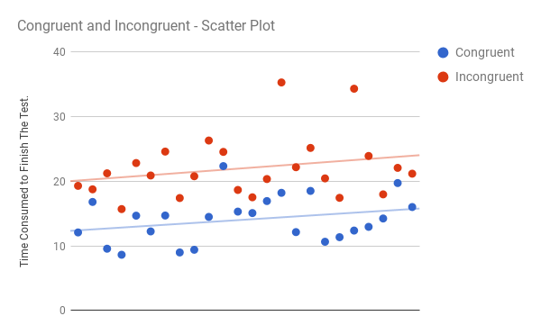

**Scatter Plot - visualization of the two samples**

Clearly, we can see that there is significant difference in time consumed between Incongruent and congruent in most of sample data by observing the trend line.

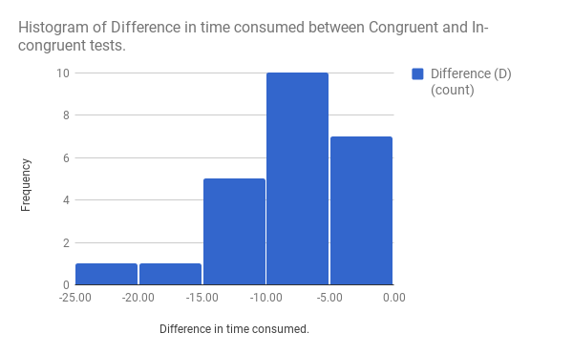

**Histogram of Difference between the samples**

This is a histogram representing the differences of time consumed to finish tests Congruent and Incongruent. It is normalized to predict the population parameters.

5) Inferential Statistics

a) t-statistic :- -8.02

b) degrees of freedom :- 23

c) p-value :- 0.0001 (approximate value)

d) direction of the test :- one-tailed - negative

e) confidence level :- 0.05 or 5%

f) t-critical value :- -1.714

t(23) = -1.64, p < 0.05, one-tailed.

95% C.I. = (-6.26, -9.67)

The difference is extremely statistically significant, Hence Rejecting the null hypotheses (H0).

Hence, it can be observed that it takes more time to finish In-Congruent tests compared to Congruent tests in Stroop Effect.